k8s-04 tsaks
- Deploy an application using a Deployment with 3 replicas and a rolling update strategy.
Step 1 — Create Deployment YAML
nano nginx-deployment. Yaml
Add:
apiVersion: apps/v1
kind: Deployment

metadata:
name: nginx-deployment

spec:
replicas: 3

strategy:
type: RollingUpdate
rollingUpdate:
maxUnavailable: 1
maxSurge: 1

selector:
matchLabels:
app: nginx-deploy

template:
metadata:
labels:
app: nginx-deploy

spec:
containers:
- name: nginx
image: nginx:1.25
ports:
- containerPort: 80 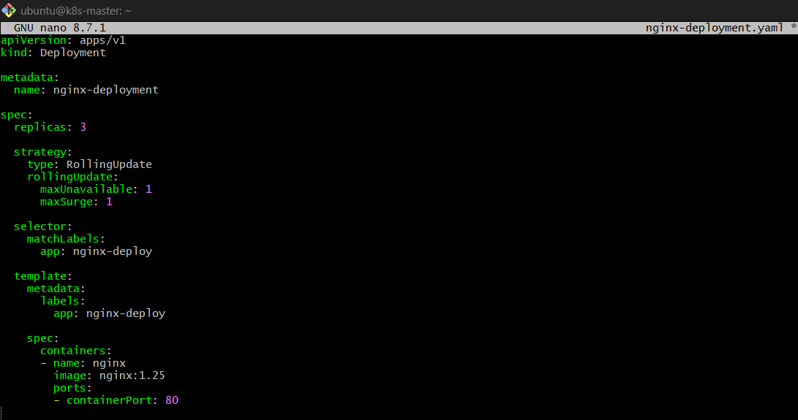

Step 2 — Create Deployment
kubectl apply -f nginx-deployment.yaml
Expected:
deployment.apps/nginx-deployment created 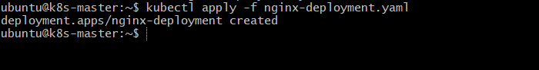

Step 3 — Verify Deployment
kubectl get deployment
Expected:
NAME READY UP-TO-DATE AVAILABLE
nginx-deployment 3/3 3 3
Check Pods:
kubectl get pods
You should have 3 Nginx Pods. 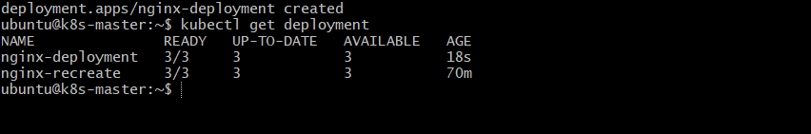

Step 4 — Check Rolling Update Strategy
kubectl describe deployment nginx-deployment
Look for:
StrategyType: RollingUpdate
And:
Max Unavailable: 1
Max Surge: 1
What do these mean?
replicas: 3
Kubernetes wants 3 running Pods.
maxUnavailable: 1
Maximum 1 old Pod can be unavailable during the update.
maxSurge: 1
Kubernetes can temporarily create 1 extra Pod during the update.
So during the update, you may temporarily see:
Old Pods + New Pods
2 + 1
or:
Old Pods + New Pods
1 + 2
Eventually:
Old Pods = 0
New Pods = 3
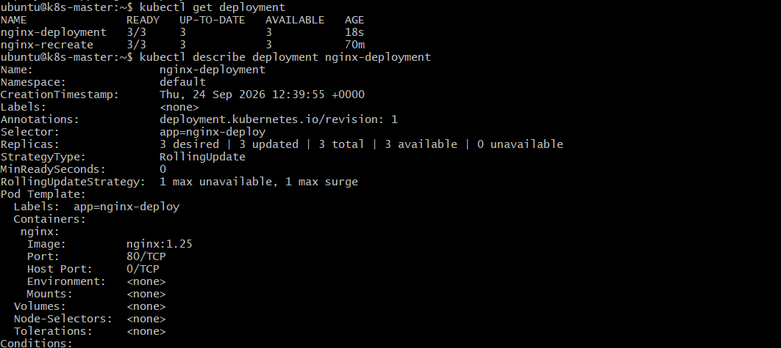

Step 5 — Perform Rolling Update
Change the image from:
image: nginx:1.25
to:
image: nginx:1.27
Then apply:
kubectl apply -f nginx-deployment.yaml
Or directly:
kubectl set image deployment/nginx-deployment nginx=nginx:1.27

Step 6 — Watch the Update
kubectl rollout status deployment nginx-deployment
You should eventually see:
deployment "nginx-deployment" successfully rolled out
You can also watch Pods:
kubectl get pods -w
You will see old Pods being terminated and new Pods being created. 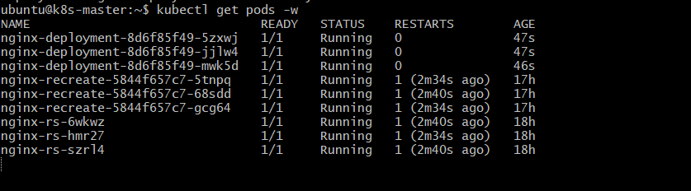

Step 7 — Verify Final State
kubectl get deployment
Expected:
NAME READY UP-TO-DATE AVAILABLE
nginx-deployment 3/3 3 3 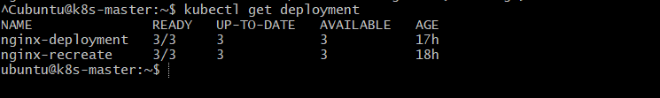

Check image:
kubectl describe deployment nginx-deployment
The new Pods should use:
nginx:1.27 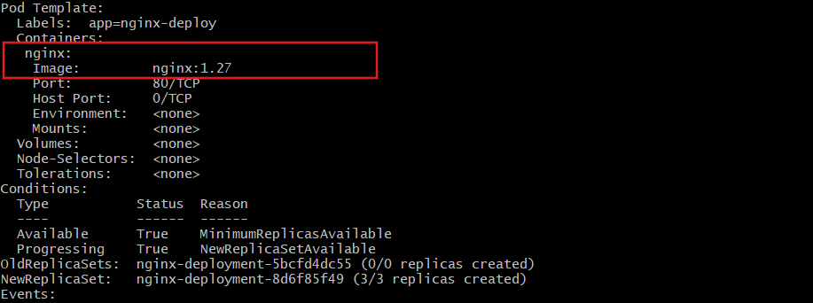

- Configure a Deployment with a Recreate strategy and observe the downtime.
Purpose
To understand the Recreate deployment strategy, where Kubernetes:
- Deletes all existing Pods.
- Then creates new Pods with the updated version.
- This causes downtime during the update.
Unlike RollingUpdate, old and new Pods do not run at the same time.

Step 1 — Create Deployment
nano nginx-recreate.yaml
Add:
apiVersion: apps/v1
kind: Deployment

metadata:
name: nginx-recreate

spec:
replicas: 3

strategy:
type: Recreate

selector:
matchLabels:
app: nginx-recreate

template:
metadata:
labels:
app: nginx-recreate

spec:
containers:
- name: nginx
image: nginx:1.25
ports:
- containerPort: 80 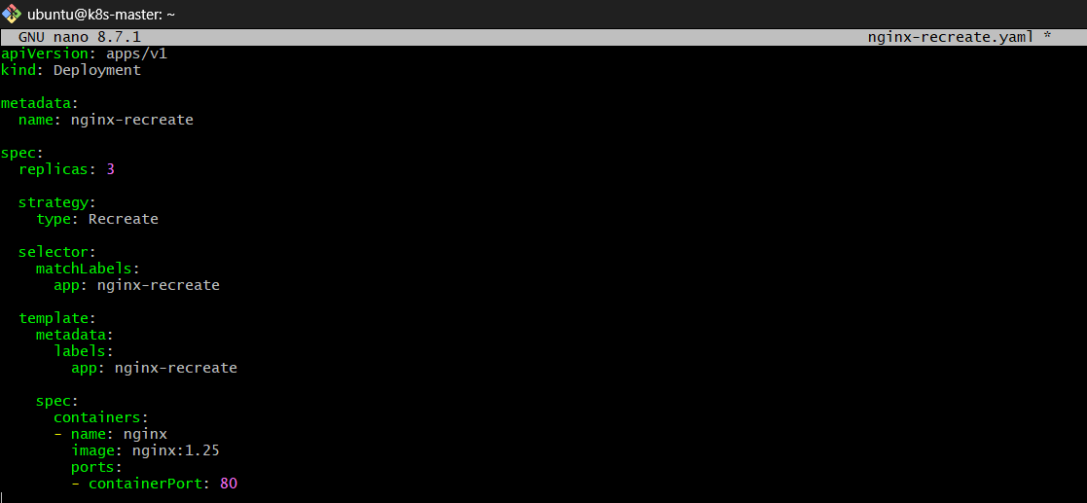

Step 2 — Create Deployment
kubectl apply -f nginx-recreate.yaml
Verify:
kubectl get deployment
Expected:
NAME READY UP-TO-DATE AVAILABLE
nginx-recreate 3/3 3 3 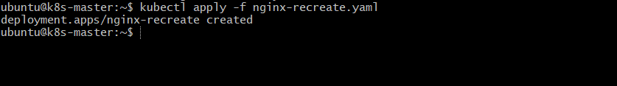
Check Pods:
kubectl get pods -l app=nginx-recreate
You should see 3 Pods. 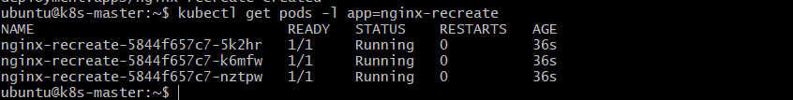

Step 3 — Update the Application
Change:
image: nginx:1.25
to:
image: nginx:1.27 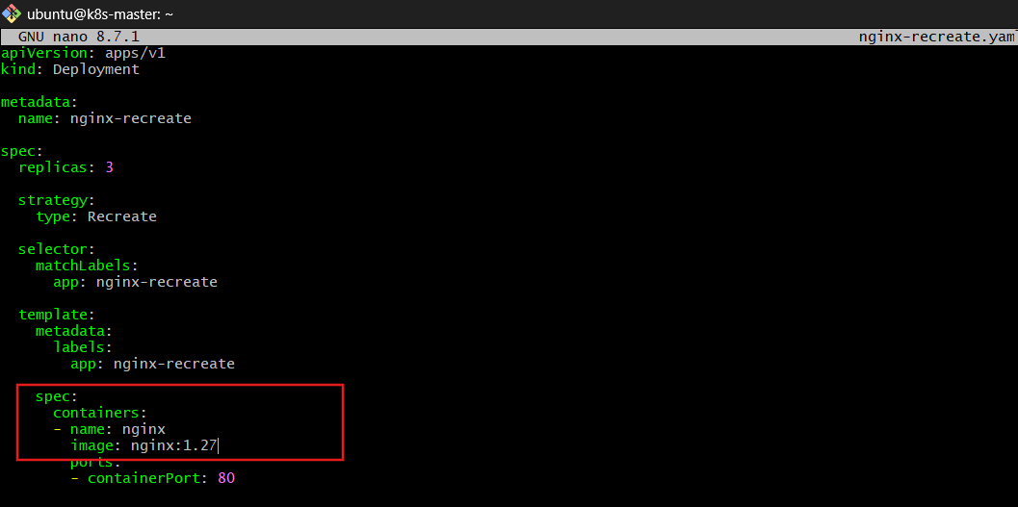
Then:
kubectl apply -f nginx-recreate.yaml 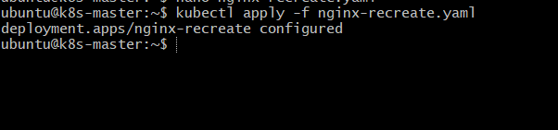

Step 4 — Observe the Recreate Strategy
Immediately run:
kubectl get pods -l app=nginx-recreate -w
You will see the old Pods being terminated:
nginx-xxxxx Terminating
nginx-yyyyy Terminating
nginx-zzzzz Terminating
For a period:
No Pods
Then Kubernetes creates the new Pods:
nginx-aaaaa ContainerCreating
nginx-bbbbb ContainerCreating
nginx-ccccc ContainerCreating
Eventually:
3 Pods Running 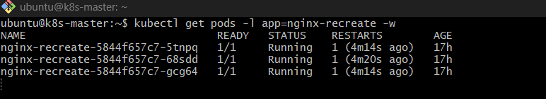

How it works
Before update
Deployment
|
├── Pod 1 → nginx:1.25
├── Pod 2 → nginx:1.25
└── Pod 3 → nginx:1.25

- Update an existing Deployment and perform a rollback to the previous version.
Purpose
To update the application version in a Deployment and roll back to the previous version if the new version has a problem.
Step 1 — Check Existing Deployment
kubectl get deployment
kubectl get pods
Assume your Deployment is:
nginx-deployment 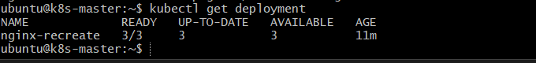

Step 2 — Check Current Image
kubectl describe deployment nginx- recreate
You may see:
Image: nginx:1.25 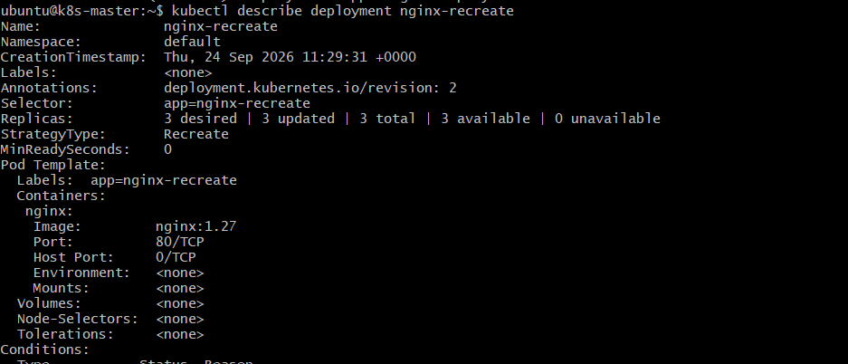

Step 3 — Update the Deployment
Update Nginx from 1.25 to 1.27:
kubectl set image deployment/nginx-deployment nginx=nginx:1.27
Check the rollout:
kubectl rollout status deployment/nginx- recreate

Verify:
kubectl get pods 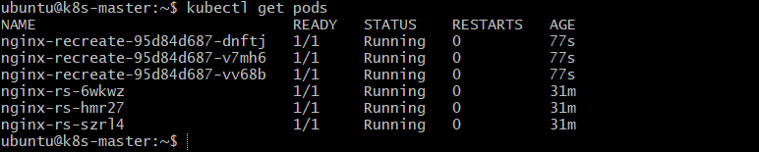
kubectl describe deployment nginx- recreate

Step 4 — Check Rollout History
kubectl rollout history deployment/nginx- recreate
Example:
REVISION CHANGE-CAUSE
1 <none>
2 <none> 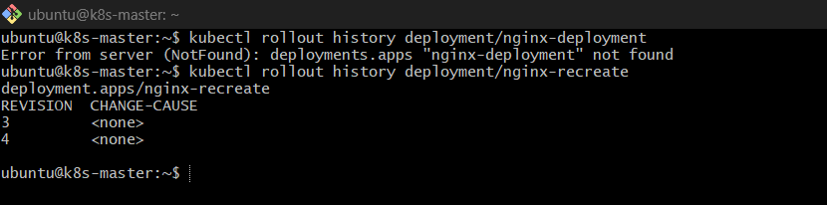

Step 5 — Rollback to Previous Version
If nginx:1.27 has a problem:
kubectl rollout undo deployment/nginx- recreate
Check:
kubectl rollout status deployment/nginx- recreate 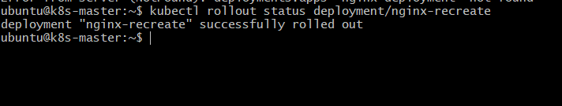

Step 6 — Verify Rollback
kubectl describe deployment nginx-recreate
You should see the previous image again:
Image: nginx:1.25 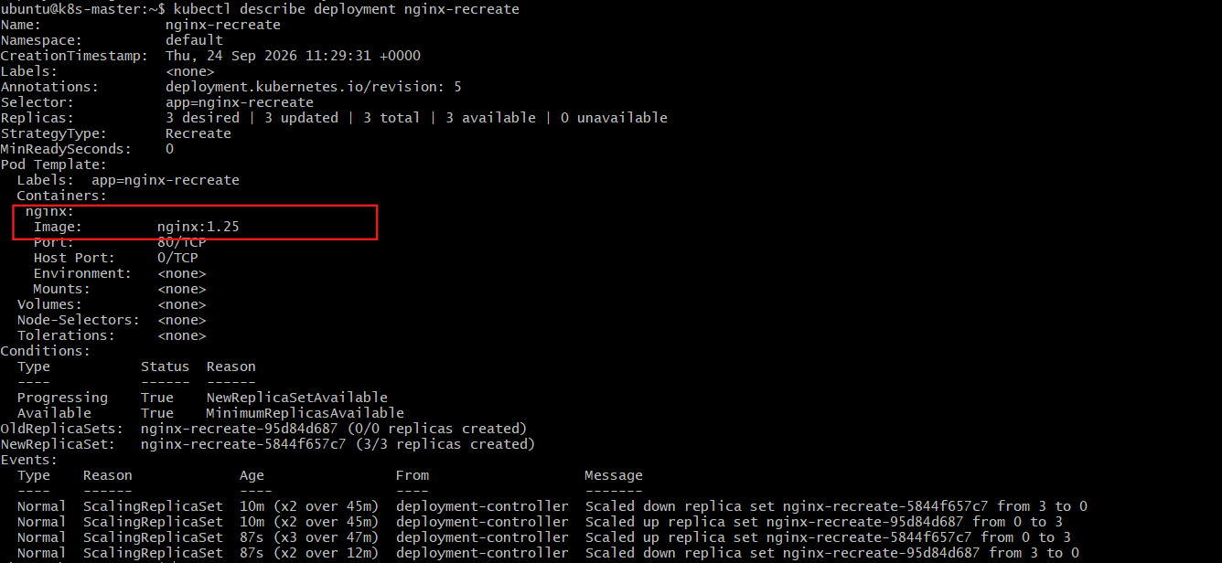
Also check:
kubectl get pods 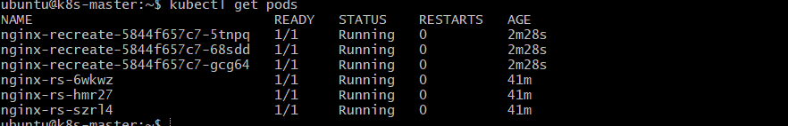

How it works
nginx:1.25
↓
Update
↓
nginx:1.27
↓
Problem found
↓
kubectl rollout undo
↓
nginx:1.25

- Modify a Deployment to add resource requests and limits for CPU and memory.
Purpose
To control how much CPU and memory a Pod can request and use.
Since your existing Deployment is nginx-recreate, we will modify that.
Step 1 — Check current Deployment
kubectl get deployment nginx-recreate 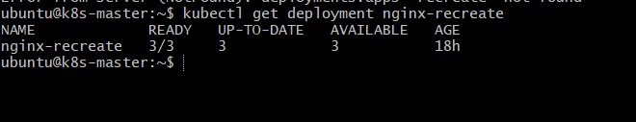
Step 2 — Edit the Deployment
kubectl edit deployment nginx-recreate
Find:
containers:
- name: nginx
image: nginx:1.27
Add resources:
containers:
- name: nginx
image: nginx:1.27
resources:
requests:
cpu: "100m"
memory: "128Mi"
limits:
cpu: "200m"
memory: "256Mi"
Save and exit.
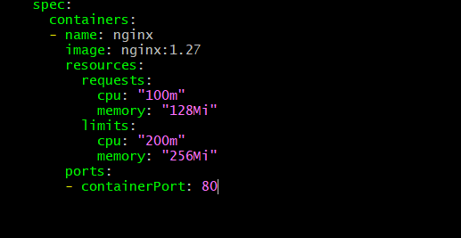

Step 3 — Check the rollout
Because your Deployment uses Recreate strategy, Pods will be recreated.
kubectl rollout status deployment/nginx-recreate
Step 4 — Verify
kubectl describe deployment nginx-recreate
Look for:
Requests:
cpu: 100m
memory: 128Mi
Limits:
cpu: 200m
memory: 256Mi 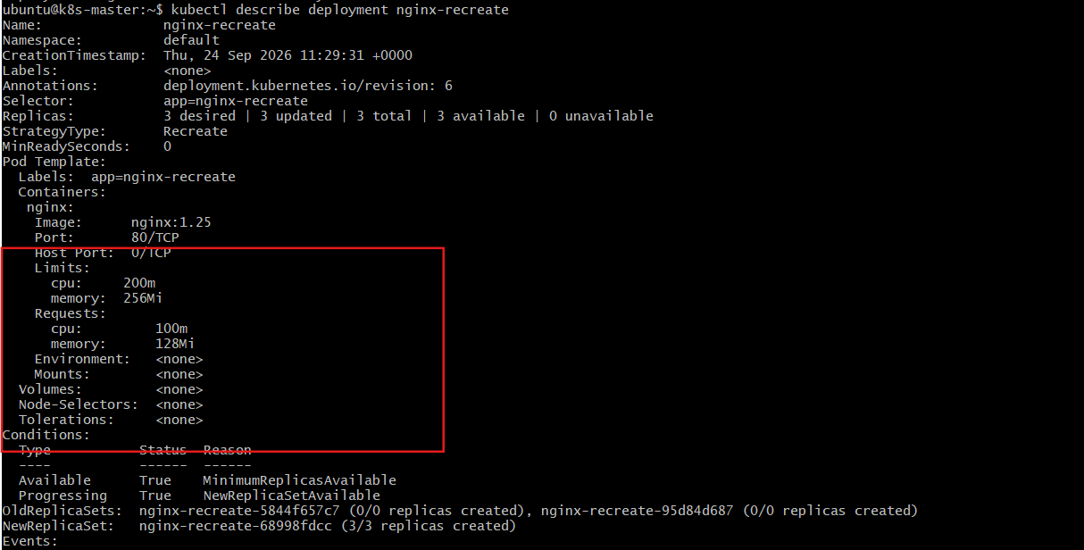
You can also check the Pod:
kubectl describe pod <pod-name>
How it works
Requests
↓
Minimum CPU/Memory Kubernetes tries to reserve for the container

Limits
↓
Maximum CPU/Memory the container can use

- Create a Deployment with MaxSurge and MaxUnavailable configurations.
Purpose
To control how many Pods can be created or unavailable during a Rolling Update.
maxSurge = extra Pods allowed during update
maxUnavailable = maximum Pods that can be unavailable during update
Step 1 — Create YAML
nano nginx-rolling.yaml
Add:
apiVersion: apps/v1
kind: Deployment
metadata:
name: nginx-rolling
spec:
replicas: 4

strategy:
type: RollingUpdate
rollingUpdate:
maxSurge: 1
maxUnavailable: 1

selector:
matchLabels:
app: nginx-rolling

template:
metadata:
labels:
app: nginx-rolling
spec:
containers:
- name: nginx
image: nginx:1.25
ports:
- containerPort: 80

Save and exit. 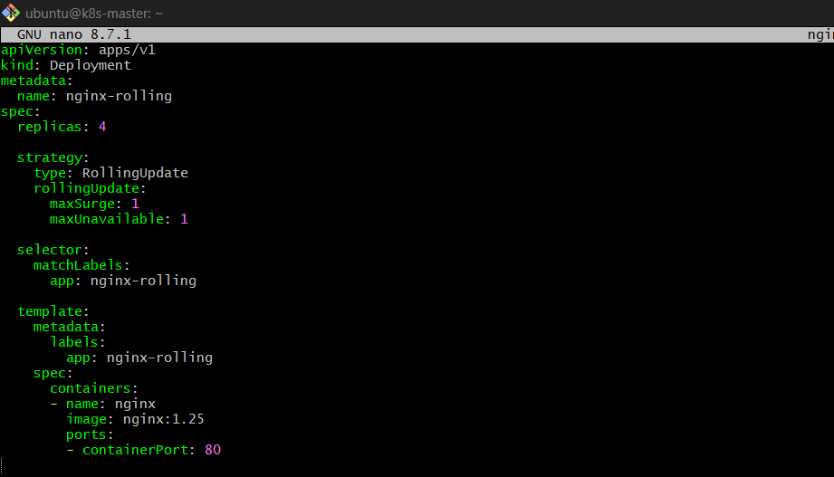
Step 2 — Create Deployment
kubectl apply -f nginx-rolling.yaml 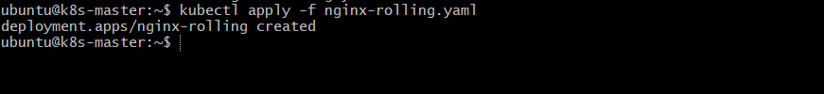
Step 3 — Verify
kubectl get deployment nginx-rolling
kubectl get pods -l app=nginx-rolling
You should have 4 Pods. 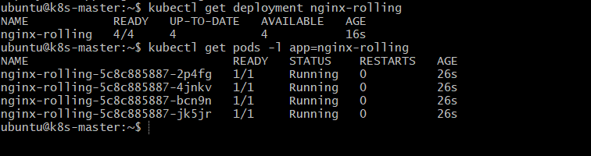
Step 4 — Perform an Update
Change the image:
kubectl set image deployment/nginx-rolling nginx=nginx:1.27 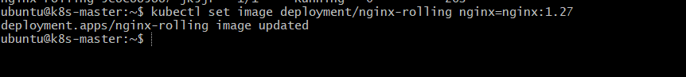
Watch the update:
kubectl get pods -l app=nginx-rolling -w
In another terminal:
kubectl rollout status deployment/nginx-rolling
Step 5 — Verify Configuration
kubectl describe deployment nginx-rolling
Look for:
StrategyType: RollingUpdate

RollingUpdateStrategy:
MaxUnavailable: 1
MaxSurge: 1
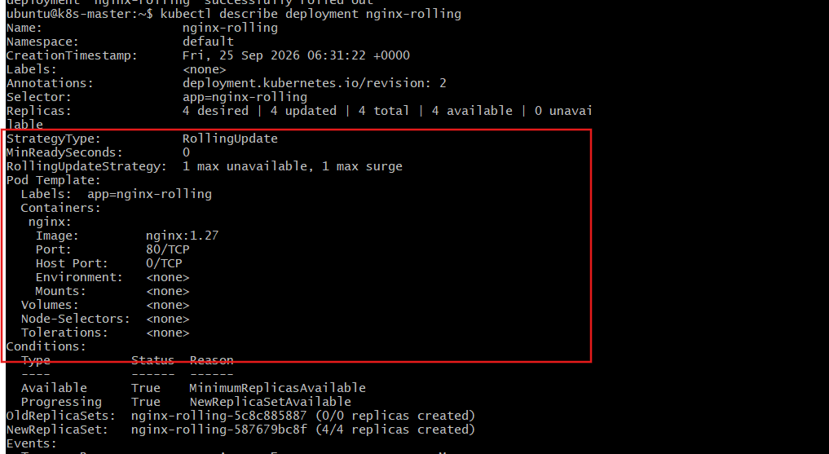
How it works
With 4 replicas:
replicas = 4
maxSurge = 1
maxUnavailable = 1
During the update, Kubernetes can temporarily have:
Maximum Pods = 4 + 1 = 5
and at most:
Unavailable Pods = 1
So Kubernetes gradually replaces the old Pods with new Pods while keeping the application available.

- Set up a Deployment with a custom revision history limit.
Purpose
To control how many old ReplicaSets Kubernetes keeps for rollback.
For example:
revisionHistoryLimit: 3
Kubernetes keeps the last 3 old revisions.
Step 1 — Create YAML
nano nginx-history.yaml
Add:
apiVersion: apps/v1
kind: Deployment
metadata:
name: nginx-history
spec:
replicas: 3
revisionHistoryLimit: 3

strategy:
type: RollingUpdate

selector:
matchLabels:
app: nginx-history

template:
metadata:
labels:
app: nginx-history
spec:
containers:
- name: nginx
image: nginx:1.25
ports:
- containerPort: 80
Save and exit. 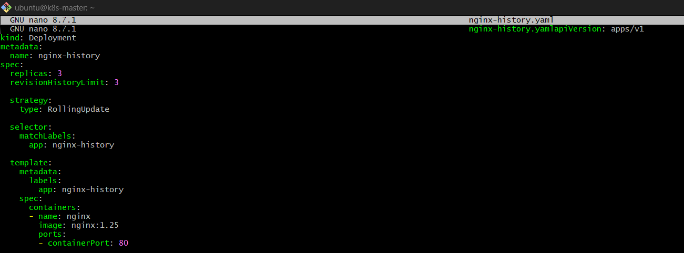
Step 2 — Create Deployment
kubectl apply -f nginx-history.yaml 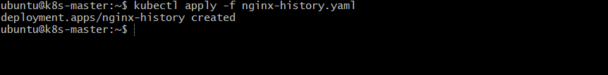

Step 3 — Verify
kubectl get deployment nginx-history 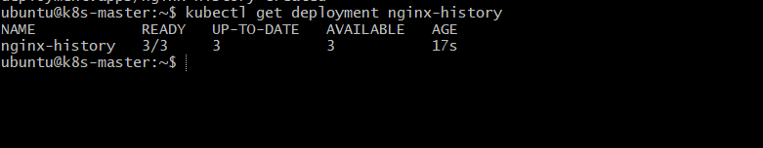
Check the revision history limit:
kubectl describe deployment nginx-history
You can also check:
kubectl get deployment nginx-history -o yaml | grep revisionHistoryLimit
Expected:
revisionHistoryLimit: 3 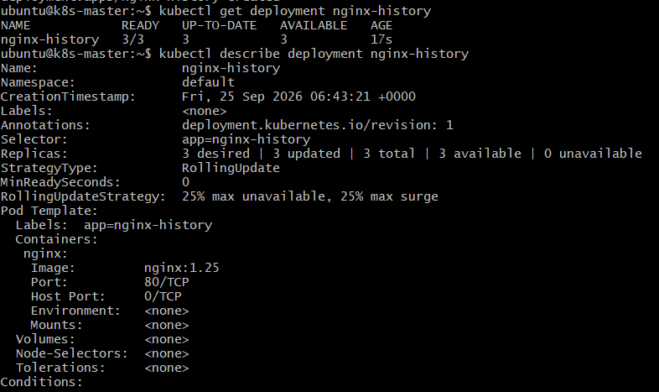
Step 4 — Create Multiple Revisions
Update the image several times:
kubectl set image deployment/nginx-history nginx=nginx:1.26
kubectl rollout status deployment/nginx-history 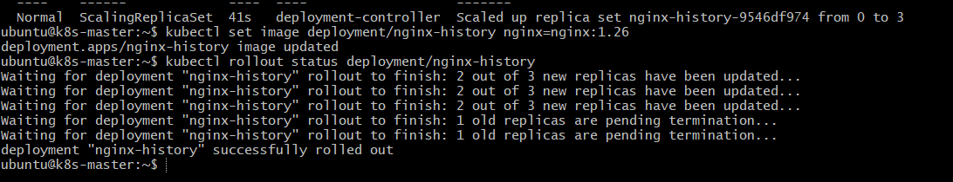

kubectl set image deployment/nginx-history nginx=nginx:1.27
kubectl rollout status deployment/nginx-history 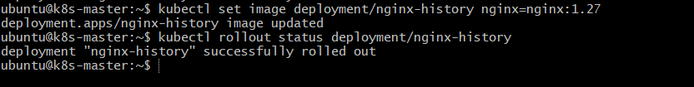

kubectl set image deployment/nginx-history nginx=nginx:1.28
kubectl rollout status deployment/nginx-history
Step 5 — Check History
kubectl rollout history deployment/nginx-history
Check ReplicaSets:
kubectl get rs 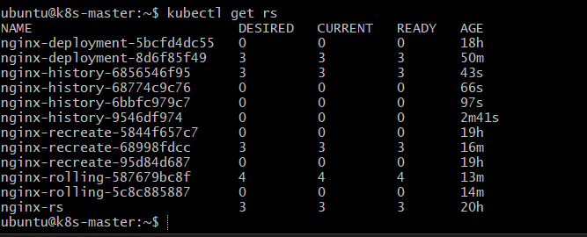

How it works
revisionHistoryLimit: 3
↓
Keep last 3 old ReplicaSets
↓
Older ReplicaSets are removed
↓
Less cluster resource usage
Important: revisionHistoryLimit controls old ReplicaSets, not the number of running Pods.
For example:
replicas: 3
revisionHistoryLimit: 3
means 3 current Pods + up to 3 old revisions kept for rollback.

- Pause a Deployment during an update, and then resume it.
Purpose
To pause a Deployment, make multiple changes without immediately rolling them out, and then resume the Deployment.
We can use your existing nginx-history Deployment.
Step 1 — Check Deployment
kubectl get deployment nginx-history 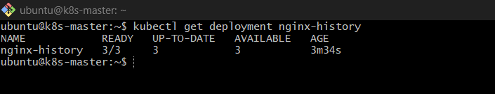
Step 2 — Pause the Deployment
kubectl rollout pause deployment/nginx-history 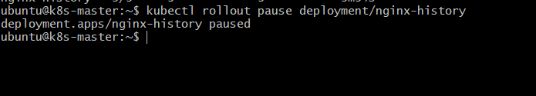
Verify:
kubectl rollout status deployment/nginx-history 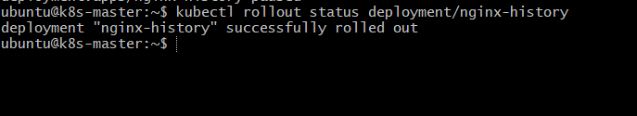
Step 3 — Make an Update
Change the image:
kubectl set image deployment/nginx-history nginx=nginx:1.26 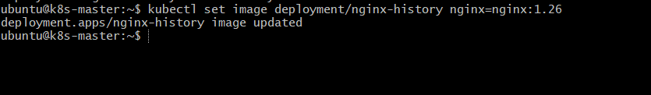
Make another change, for example:
kubectl set resources deployment/nginx-history -c=nginx --requests=cpu=100m,memory=128Mi --limits=cpu=200m,memory=256Mi 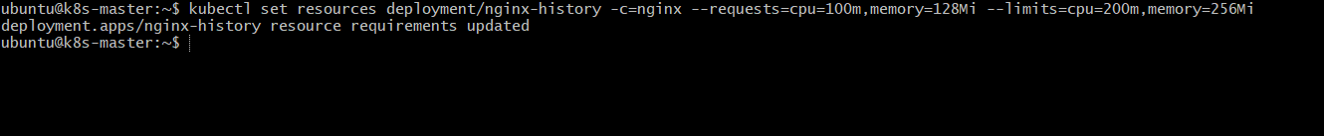
Because the Deployment is paused, these changes are not rolled out yet.
Check:
kubectl get pods 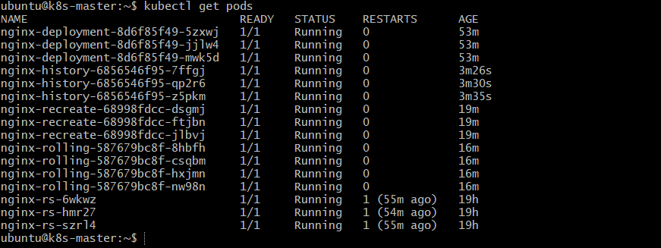
Step 4 — Resume the Deployment
kubectl rollout resume deployment/nginx-history 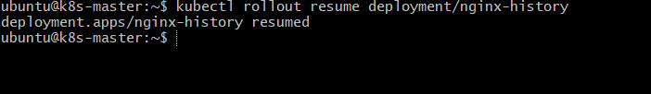
Step 5 — Monitor the Rollout
kubectl rollout status deployment/nginx-history
Check Pods:
kubectl get pods -l app=nginx-history
Step 6 — Verify Image
kubectl get deployment nginx-history -o wide 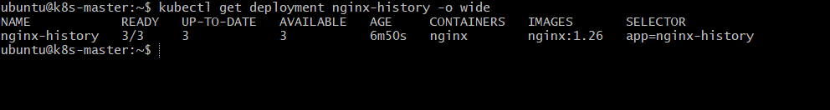
You should see:
IMAGES
nginx:1.26
How it works
Deployment
↓
rollout pause
↓
Make changes
↓
Changes wait
↓
rollout resume
↓
Changes rolled out
Important commands
kubectl rollout pause deployment/nginx-history
kubectl set image deployment/nginx-history nginx=nginx:1.26
kubectl rollout resume deployment/nginx-history
kubectl rollout status deployment/nginx-history
Use case: Pause is useful when you want to make multiple related changes and deploy them together instead of triggering a rollout after each change.

- Create a pod using resource requests for memory and CPU, and observe how the scheduler assigns it to a node.
Purpose
To understand how CPU and memory requests influence the Kubernetes Scheduler when selecting a worker node.

Step 1 — Check Nodes
Run on the master:
kubectl get nodes
Check node resource information:
kubectl describe nodes 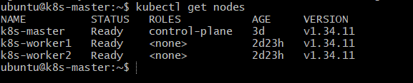

Step 2 — Create Pod YAML
nano resource-pod.yaml
Add:
apiVersion: v1
kind: Pod
metadata:
name: resource-pod
spec:
containers:
- name: nginx
image: nginx
resources:
requests:
cpu: "500m"
memory: "512Mi"
Save and exit. 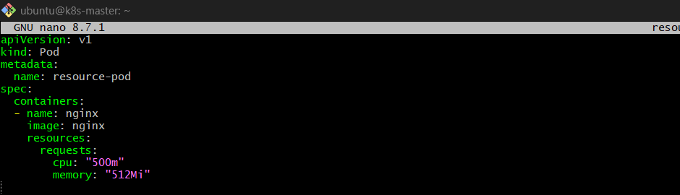

Step 3 — Create the Pod
kubectl apply -f resource-pod.yaml

Step 4 — Check Pod Status
kubectl get pod resource-pod -o wide
Example:
NAME READY STATUS IP NODE
resource-pod 1/1 Running 10.244.x.x k8s-worker1
The NODE column shows where the Scheduler placed the Pod. 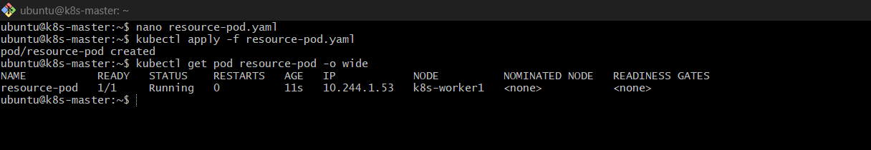

- Step 5 — Check Scheduling Details
kubectl describe pod resource-pod
Look at:
Node: k8s-worker1/172.31.x.x
At the bottom, check:
Events:
Normal Scheduled ... Successfully assigned default/resource-pod to k8s-worker1
This confirms that the Scheduler assigned the Pod to that node. 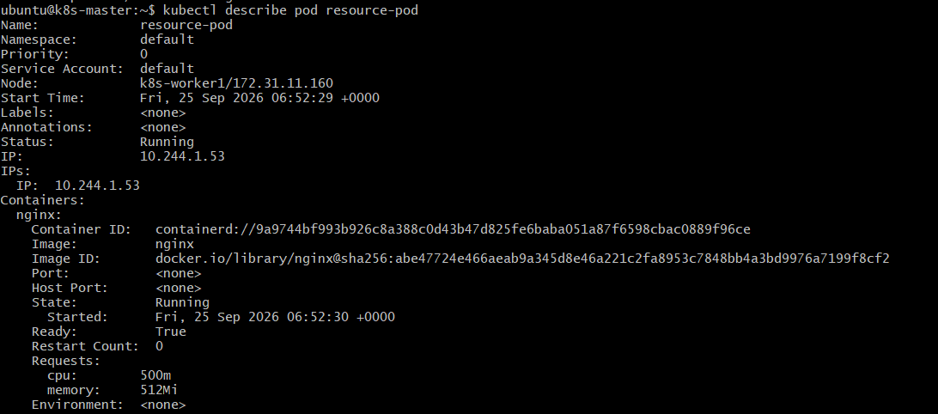

Step 6 — Check Resource Requests
kubectl describe pod resource-pod
You should see:
Requests:
cpu: 500m
memory: 512Mi 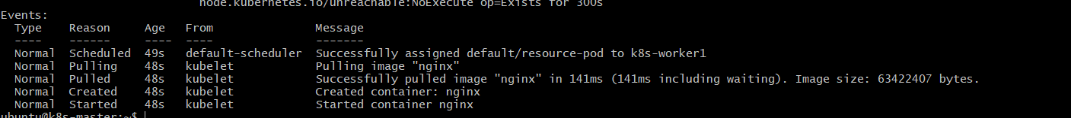

- How it works
Pod YAML
↓
CPU request = 500m
Memory request = 512Mi
↓
Kubernetes Scheduler checks nodes
↓
Finds a node with enough available resources
↓
Pod assigned to that node
Important Point
The Scheduler mainly considers resource requests, not actual current CPU/memory usage.
For example:
Worker 1 → Not enough available CPU
Worker 2 → Enough CPU + Memory
Worker 3 → Enough CPU + Memory

↓

Scheduler
↓
Worker 2
So the Pod is scheduled on a node where its requested resources can be accommodated.

